THE MAGNETIC FIELD
  - Introduction
The space around a magnet or a current–carrying conductor, where a magnetic force is experienced is called a magnetic field. The magnetic field like electric field, is a vector field, and its magnitude and direction at any point is given by a vector 𝐵. This vector is called the magnetic induction or the magnetic flux density and its magnitude is given by
𝐵 = 𝜙 …………………………….3.1
A
where 𝜙 is the magnetic flux passing through a surface and A is the area of the surface at right angles to the magnetic field. The S.I unit of magnetic flux density is Tesla (T) while magnetic flux is measured in weber (Wb).
Sometimes, magnetic flux density is expressed in weber per metre squared (Wbm⁻²). 1Wbm⁻² = IT.

Magnetic Lines of Force
A magnetic field can be represented by lines such that the tangent to a line through a given point gives the direction of the magnetic field at that point. These lines are called lines of Induction or lines of forces. The lines of force are drawn so that their relative spacing is

proportional to the magnitude of the magnetic field. When the lines are close together at a point, the magnetic field at that point is large, and when they are far apart, the magnetic field is small.
Magnetic Lines of force do not cross each other; they start from a North pole and end up on a South pole of a magnet.
Fig 3.1: Shows a few of the lines of force in typical magnetic fields.

The points marked (X) in Fig 3.1 are called neutral points. A neutral point is where the result magnetic field, due to two magnets, is zero.

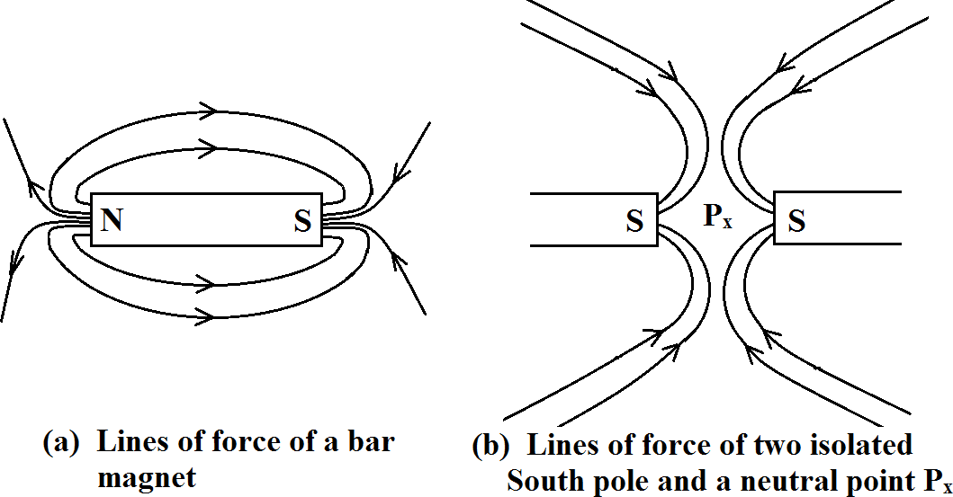

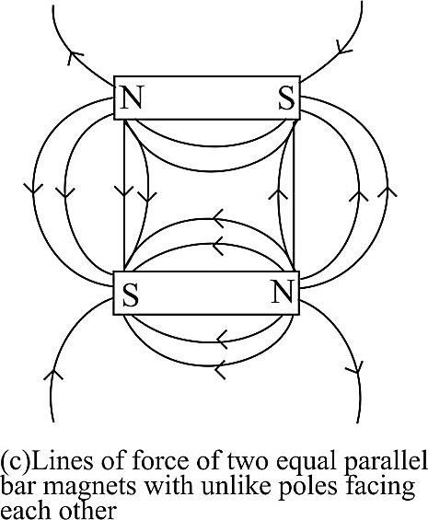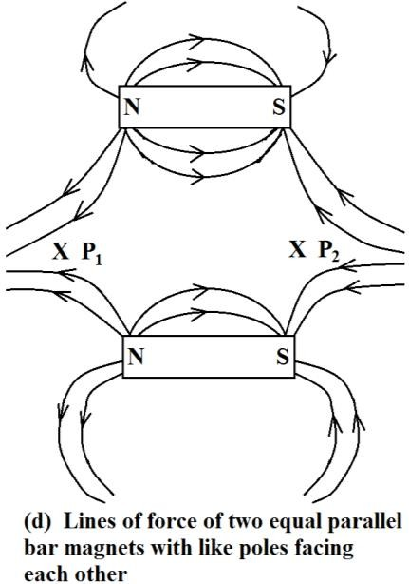
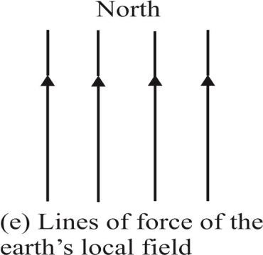
Fig 3.1

Worked Examples
- Calculate the flux density of a magnetic material of cross-sectional area 4cm² with a total flux of 6Wb through it.

The magnetic flux density, B = 𝜙
A

= 6
4× 10−4 m2
= 15000T

- If the permeability of free space is 4𝜋 × 10⁻⁷Hm⁻¹; calculate the flux density produced in air by a magnetic field strength of 20,000Am⁻¹

Magnetic flux density, B =Uo H
where 𝜇u₀ = permeability of free space
H= Magnetic field strength or magnetic intensity
∴ 𝐵 = 4𝜋 × 10⁻⁷ × 20, 000 = 0.025T

  - Motion of Charged Particles in a Magnetic Field A charged particle moving in a magnetic field experiences a magnetic force which acts perpendicularly to both the directions of motion of the charged particle and the field. The magnitude of the force, F is found to be proportional to:
- the speed, u of the charged particle,
- the magnitude of the charge, q
- the magnetic flux density, B
- the sine of the angle, 𝜃 between u and B

Mathematically,

𝐹 𝛼 𝑞𝑢𝐵 sin 𝜃 3.2
If the unit of the magnetic flux density is such that a charge of one coulomb moving with a speed of m/s perpendicularly to a field of unit flux density experiences a force of one newton, then the constant of proportionality will be unity.
∴ 𝐹 = 𝑞𝑢𝐵 sin𝜃 3.3
𝐵 is in Tesla.
Equation 3.3 can equally be written as
𝐹 = q𝑢 × 𝐵 3.4

where 𝑢 × 𝐵 is pronounced as 𝑢 cross B. It can easily be seen that in equation 3.3, if 𝑢 = 0, 𝐹 = 0. This implies that a stationary charged body experiences no force in a magnetic field. If 𝑢 is parallel to B (𝜃 = 0⁰), then 𝐹 = 0, no force is experienced by the charge. If 𝑢 is perpendicular to 𝐵 (𝜃 = 90⁰), a maximum force will be experienced by the charge and is given by
𝐹 = 𝑞𝑢𝐵 ……………………..3.5
The magnetic force deflects the charged particle but does not change its speed or kinetic energy (Fig 3.2). The path traversed by the particle is a circle. This means that the magnetic force acts towards the centre of the circle and is normal to u. Hence, the fore is a centripetal force.

.˙. ^{𝑚𝑢}2
𝑞𝐵
= 3.6
r = mu

…….….3.6

where 𝑟 is the radius of the circle traced out by the charge and 𝑚 is the mass of the charge.
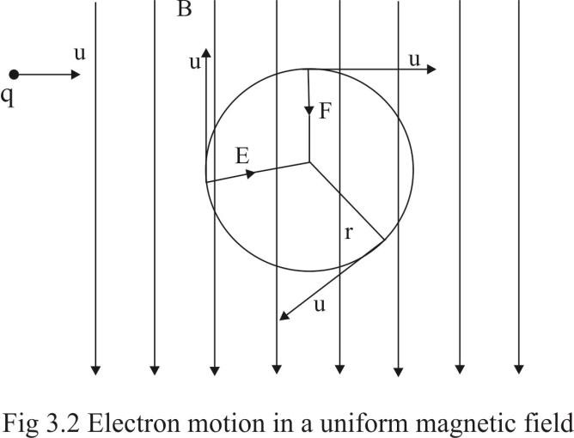

If an electric field 𝐸 is present as well as magnetic field
𝐵, the charge experiences an additional force 𝑞𝐸 and the total force is
F = qE + qusin𝜃 3.7
If the charge moves perpendicular to the two fields and suffers no deflection, then the electric force 𝑞𝐸 on it must be equal and opposite to the magnetic force 𝑞𝑢𝐵. Hence,
qE = quB
Or E = uB 3.8

Worked Examples
- A charge of 1.6 × 10⁻¹⁹C enters a magnetic field of flux density 2.0T with a velocity of 2.5 × 10⁷ms⁻¹ at an angle of 30° with the field. Calculate the magnitude of the force exerted on the charge by the field.
F =quB sin𝜃
= 1.6 × 10⁻¹⁹ × 2.5 × 10⁷× 2.0 × sin 30
= 4.0 × 10⁻¹²N.
- An electron moves in a circular path of radius 1.2cm perpendicular to a uniform magnetic field. The velocity of the electron is 10⁶ms⁻¹. Calculate the magnetic flux density.

B =
mu

qr
m is the mass of electron = 9.1 × 10⁻³¹kg,
𝑞 = 1.6 × 10⁻¹⁹C, 𝑟 = 0.012m
.˙. 𝐵 = 9.1 × 10−31×106
1.6 × 10−19×0.012
= 4.74 × 10⁻⁴T
- An ion, for which the charge per unit mass is 4.4 × 10⁷Ckg⁻¹, has a velocity of 3.52 × 10⁵ms⁻¹ and moves in a circular orbit in a magnetic field of flux density 0.4T. What will be the radius of this orbit?

r =
mu

qB
𝑢 = 3.52 × 10⁵ms⁻¹, 𝐵 = 0.4T,
m 1
𝑞 = 4.4 × 10⁷Ckg⁻¹

.˙. 𝑟 = 1
4.4 × 107
× 3.52 ×105 = 0.02m
0.4

- Consider a proton travelling due west at a velocity of 5 × 10⁵ms⁻¹. Assuming that the earth's magnetic field has a strength of 5 × 10⁻⁵T and is directed due south. Calculate:
  - the magnitude of the force on the proton,
  - the acceleration of the proton.

- F = quB
𝑞 = 1.6 × 10⁻¹⁹𝐶, 𝑢 = 5 × 10⁵ms⁻¹, 𝐵 = 5 × 10⁻⁵T
.˙. 𝐹 = 1.6 × 10⁻¹⁹ × 5 × 10⁵ × 5 × 10⁻⁵
𝐹 = 4 × 10⁻¹⁸ N.
- Acceleration, a = f
m
𝐹 = 4 × 10⁻¹⁸ N, 𝑚 = 1.67 × 10⁻²⁷ kg

.˙. 𝑎 = 4 ×10−18
1.67 ×10−27
= 2.40 × 10⁹ ms⁻²

- A beam of proton is accelerated from rest through a potential difference of 2000V and then enters a uniform

magnetic field which is perpendicular to the direction of the proton beam. If the flux density is 0.2T, calculate the radius of the path which the beam described. (Proton mass = 1.7 × 10⁻²⁷kg, electron charge= 1.6 × 10⁻¹⁹ C)

r =
mu

qB

But 𝑢 = √2𝑞𝑉
m

.˙. 𝑟 = 𝑚
qB
√2𝑞𝑉
m

1
R =
B
2mV
√
q

1 2 × 1.7 × 10⁻²⁷ × 2000

𝑟 = √ 0.2
1.6 × 10⁻¹⁹

= 0.0326m
= 32.6mm
- An electron emitted from a hot filament in an evacuated tube is accelerated by a p.d of 4000V and then enters at right angles to a uniform magnetic field of flux density 1 × 10⁻³T. Calculate the:
  - Speed of the electron and determine its path in the magnetic field,

  - Intensity of the uniform electrostatic field which, when suitably applied, would compensate the effect of the magnetic field on the path of the electron.
- The speed of the electron is given by

𝑢 = 5.93 × 10⁵ × √V

= 5.93 × 10⁵ × √4000
= 3.75 × 10⁷ms⁻¹.

.˙. 𝑟 = 𝑚𝑢 = 9.1 ×10−31× 3.75 ×107 = 0.213m

qB
1.6 ×10−19× 1 ×10−3

.˙. The electron described a circle of radius, 0.213m in the magnetic field.

- 𝐸 = 𝑢𝐵 = 3.75 × 10⁷ × 1 × 10⁻³
= 3.75 × 10⁴ Vm⁻¹

Force on a Current – Carrying Conductor in a Magnetic Field.
When a conductor carrying an electric current is placed in a magnetic field, it experiences a mechanical force. The electric motor and the moving coil galvanometer, both depend for their operation on the force on a current – carrying conductor in a magnetic field.

Experiment has shown that the magnitude of the force on a current – carrying conductor in a magnetic field (Fig 3.5) is proportional to:
- the magnetic flux density 𝐵,
- the current, I flowing through the conductor,
- the length, l of the conductor in the field,
- the sine of the angle, θ between the conductor and the field.
Mathematically,
F Bil sin 𝜃
Or 𝐹 = k BiLsin 𝜃 (i)
where k is a constant.

When a conductor of length 1m long carrying a current of 1 ampere is placed perpendicular to a magnetic field of flux density, 1 tesla (T), a force of 1 Newton will act on it. Substituting F= 1, B= 1, l= 1 and sin 𝜃=
𝑠𝑖𝑛 90° = 1, in equation (i), then 𝑘 = 1.

Hence,
𝐹 = 𝐵𝐼𝑙 sin 𝜃 ………3.12
The maximum force occurs when 𝜃 = 90° and is given by
F = Bil
If the conductor is placed parallel to the field, then
F = 0. This implies that it will experience no force.

To find the direction of the force on a current – carrying conductor placed in a magnetic field, we make use of Flemings left-hand rule. This states that if we place the thumb, the Forefinger and the Second finger of the left hand so that they are all perpendicular to each other and we point the Forefinger in the direction of the magnetic Field and the Second finger in the direction of the Current, then the thumb will point in the direction of the Motion (Fig 3.5.1).
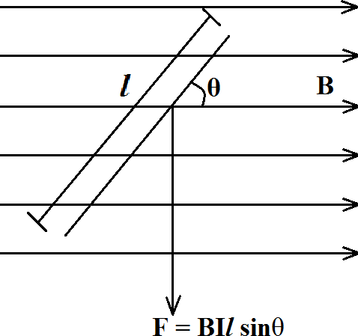
Fig 3.5.1 Current-carrying conductor in a magnetic field
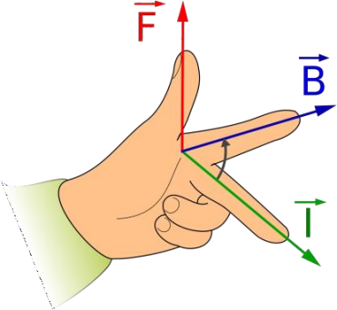
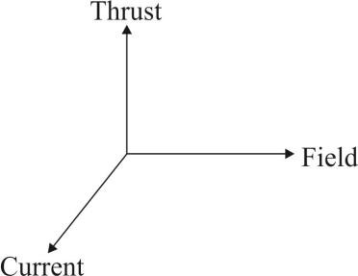
Fig 3.5.1 Fleming's left hand rule

Worked Examples
- The magnetic flux density between the poles of a powerful electromagnet is 2.5T. A wire of length
2.0 × 10⁻²m carrying a current of 4.0A is placed in the given field. Calculate the:
  - maximum force on the wire,
  - force when the wire makes an angle of 60° with the field,
  - force when the wire is parallel to the field.
F= BLI sin 𝜃
- The maximum force occurs when 𝜃 = 90°
.˙. 𝐹 = 𝐵𝐼𝑙 = 2.5 × 4 × 2.0 × 10⁻² = 0.20N
- When 𝜃 = 60°
.˙. 𝐹 = 𝐵𝐼𝑙 sin 𝜃 = 2.5 × 4 × 2.0 × 10⁻² × sin 60°
= 0.17N
- When the wire is parallel to the field, 𝜃 = 0°.
.˙. 𝐹 = 2.5 × 4 × 2.0 × 10⁻² × sin 0 = 0
- A horizontal rod 0.2m long is mounted on a balance and carries a current. In the vicinity of the wire is a uniform magnetic field of magnitude 0.05T; perpendicular to the wire. The force on the rod is measured by the balance and is found to be 0.24N. What is the current in the rod?
F= Bil since B is perpendicular to the conductor.

.˙. 𝐼 = 𝐹
𝐵𝑙
= 0.24
0.05 ×0.2
= 24A

- Calculate the force on a power cable of length 200m carrying a current of 200A in a direction N30°E at a place where the horizontal component of the Earth's magnetic field is 10⁻⁵T.
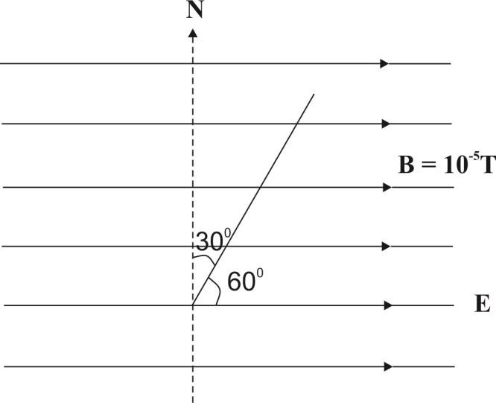
The wire will experience an upward force given by
F= Bil𝑙 sin 𝜃
𝐵 = 10⁻⁵T, 𝐼 = 200A, 𝑙 = 200m, 𝜃 = 60°
.˙. 𝐹 = 10⁻⁵ × 200 × 200 ×sin 60° = 0.35N

Torque on a Coil in a Magnetic Field
If a coil carrying a current is placed in a magnetic field it will experience a force on two of its sides in such a way as to make the coil rotate.

Consider a rectangular coil PQRS of length, l and width, b placed in a magnetic field of flux density 𝐵 and free to rotate (Fig 3.6).
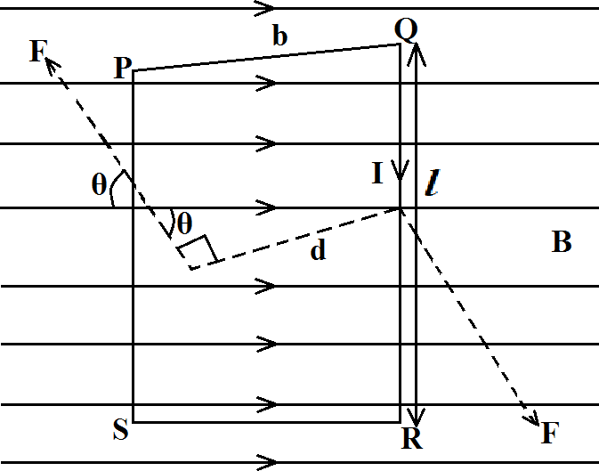
Fig 3.6 Coil in a magnetic field

A force, F is exerted on the side QR of the coil and is given by
F = BiL
The same force, but opposite in direction, is exerted on the side SP.
The two forces constitute a couple. If the number of turns on the coil is N, then
F = NBIl
If the force is perpendicular to the coil and is at an angle 𝜃 to the field direction, then the torque, 𝑇 exerted on the coil is Fd where d= b sin 𝜃
T= Fb sin 𝜃
T = NBIlsin 𝜃
.˙. 𝑇 = 𝑁𝐵𝐼𝐴 sin 𝜃
where A= lb is the area of the coil

The maximum torque occurs when 𝜃 = 90° (i.e when the side SP is parallel to the field lines) and is given by
T𝑚max𝑥 = NBIA
The minimum value of the torque is zero, when 𝜃 = 0°.

The quantity 𝑁𝐼𝐴 is called magnetic dipole moment of the coil, and is defined as the torque exerted on the coil when placed with its plane parallel to a field of unit magnitude. It is measured in Ampere per metre squared (Am⁻²)

Worked Examples
- Calculate the torque needed to hold a coil of 50 turns of area 8cm² at an angle of 60° to a field of flux density 0.1T; if the coil carries a current of 0.5A.
Torque , T= NBIA sin 𝜃
= 50 × 0.1 × 0.5 × 8 × 10⁻⁴ × sin 60°
= 1.73 × 10⁻³Nm
- What is the maximum torque on a coil 5 × 12cm, of 600 turns, when carrying a current of 10⁻⁵A in a uniform field where the flux density is 0.10Wbm⁻²?
Maximum Torque, Tmax = NBIA
𝑇𝑚𝑎𝑥 = 600 × 0.10 × 10⁻⁵ × 0.006
= 3.6 × 10⁻⁶Nm

Chapter Four
MAGNETIC EFFECT OF AN ELECTRIC CURRENT

  - Introduction
When an electric current flows in a wire, a magnetic field is produced around the wire. This was discovered in 1820 by Hans Christian Oersted, a Professor of Physics at Copenhagen.
Shortly after Oersted's observation was published, André Ampère, a French Mathematician and Physicist performed many experiments on the magnetic effect of current and showed conclusively that an electric current in a wire always gives rise to a magnetic field round it. The rule for finding the direction of the magnetic flux (lines of force) round a current carrying wire was given by James Clerk Maxwell, a great mathematical physicist. This is known as Maxwell's corkscrew rule and is stated thus:

If we imagine ourselves driving a corkscrew in the direction of the current, then the direction of rotation of the corkscrew is the direction of the lines of force.

Some of the devices which make use of the magnetic effect of an electric current in their operation are the electric bell, the telephone earpiece, the electric motor
And the lifting magnet used extensively in industry for lifting heavy masses of iron.

Magnetic Flux Patterns for Simple Arrangements of Current - Carrying Conductors
1. Magnetic flux pattern due to current in a straight wire
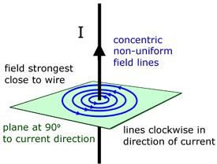
Fig 4.1(a)
- Magnetic flux pattern due to currents in two straight parallel wires.
  - when the currents flow in the same direction
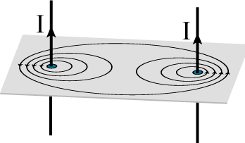
Fig 4.1(b)

  - when the currents flow in opposite directions
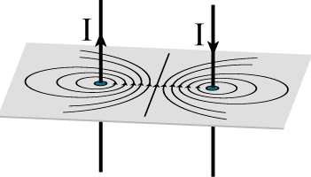
Fig 4.1(c)
- Magnetic flux pattern due to current in a circular coil
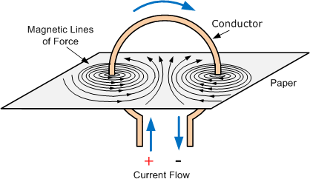
Fig 4.1(d)
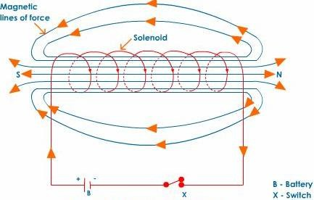
- Magnetic flux pattern due to current in a solenoid
Fig 4.1(e)

- Magnetic flux pattern due to current in a toroid
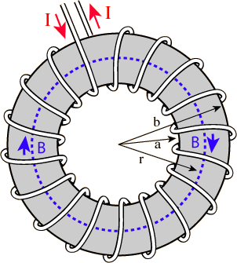
Fig 4.1(f)

Biot – Savart’s law
This states that the magnetic flux density 𝛿𝐵 at a point P due to a small element 𝑑𝑙 of a conductor carrying a current 𝐼 is given by

𝛿𝐵𝛼
ldl sin 𝜃

r2

or 𝛿𝐵 = k Idlsin 𝜃
r2
…………….4.1

where l is the distance from the point P to the element,
𝜃 is the angle between the element and the line joining it to P (Fig. 4.2) and k is a proportionality constant.

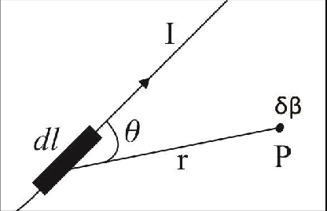
Fig 4.2
The proportionality constant 𝑘 depends on the medium in which the conductor is situated. If the conductor is in a vacuum or air, we write

𝛿𝐵 = μ0
4π
Idl sin𝜃

r2
………….4.2

Where 𝜇0 = 4𝜋 × 10⁻⁷ Hm⁻¹ is called the permeability of free space.

Worked Examples
- Calculate the magnetic flux density in air at a point 5cm from a long straight wire carrying a current of 2A.

B =

B=
𝜇0lI𝜋2a
4𝜋 × 10⁻⁷ × 2

2𝜋 × 0.05

= 8.0µT

- A long straight wire produces a field of 6.0µT at a distance of 30cm from it in vaccum. Calculate the current in the wire.

B =

I =
µ0I

2𝜋a
2𝜋aB

µ0

I =
2𝜋 × 0.30 × 6.0 × 10⁻⁶
4𝜋 × 10⁻⁷ = 9𝐴

3(a) Derive an expression for the force per unit length between two long parallel current-carrying wires.
(b)(i) Define the ampere.
(b)(ii) Two long parallel conductors, 5cm apart, are carrying currents 10A and 15A respectively in the same direction. Calculate the force of attraction per unit length between the two conductors.

(a) Consider two long parallel current-carrying wires, P and Q, separated by a distance 𝑎, carrying currents 𝐼₁ and 𝐼₂ respectively in the same direction (Fig.4.4).

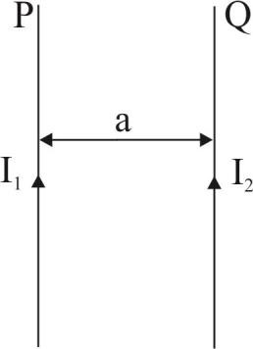
Fig 4.4
The force on wire Q as a result of field B set up by current I1 flowing in wire P is given by F = BI2 l where l is the length of wire Q But, the field B at the position of wire Q due to I₁, flowing in wire P is
𝐵 = µ0I1
2𝜋a

∴ 𝐹 = 𝜇0𝐼1
2𝜋a
× 𝐼2𝑙

F = 𝜇𝜋a0𝐼1𝐼2𝑙, directed towards wire P
2
The force per unit length is given by

F
L=
µ0
𝜇0l𝐼L1𝐼 2𝜋a

(b)(i) The ampere is the current which, if flowing in two
straight parallel wires of infinite length, placed one metre apart in a vacuum, will produce on each of the wires a force of 2 × 10⁻⁷ newton per metre length.
(bii) Force per unit length = 𝜇0𝐼1𝐼2
2𝜋$Type equation here.$𝑎

4𝜋 × 10⁻⁷ × 10 × 15
=
2𝜋 × 0.05
= 6.0 × 10⁻⁴N

- If two long parallel wires carrying respectively currents of 12A and 8A in the same direction are placed 10cm apart, find where a third parallel wire also carrying a current must be placed so that the force experienced by it shall be zero.
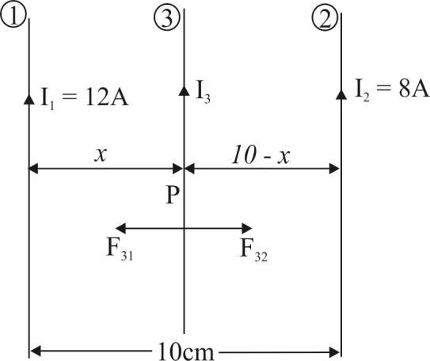

Let 𝐹31 = the force on wire 3 due to the field 𝐵1
produced by the current 𝐼₁ in wire 1.
𝐹32 = the force on wire 3 due to the field 𝐵2 set up by the current 𝐼₂ in wire 2.
F31 = F32
𝐹32 = 𝐵2𝐼3𝑙

where 𝑙 = length of wire 3. At the required position P,
𝐹31 = 𝐹32
.˙. 𝐵1𝐼3𝑙 = 𝐵2𝐼3𝑙
B1 = B2
µ0𝐼1 µ0𝐼2
2𝜋𝑥 = 2𝜋(10 − 𝑥)
𝐼₁(10 − 𝑥) = 𝐼₂𝑥 12(10 − 𝑥) = 8𝑥
3(10 − 𝑥) = 2𝑥
30 − 3𝑥 = 2𝑥
5x = 30
x = 6
This implies that the third wire must be placed at 6cm from the wire carrying a current of 12A (i.e. wire 1) or 4cm from wire 2.

2(a) Draw the magnetic flux pattern due to an electric current in a circular coil.
(b) A circular loop of wire of radius 40cm carrying a current of 3.5A is situated in a vacuum. Calculate the magnetic flux density at the centre of the loop.

3(a) Write down an expression for the magnetic flux density on the axis of a long solenoid, explaining all the symbols involved.
(b) A solenoid of diameter 4cm is 50cm long and has 500 turns. If a current of 20A flows in the wire, calculate the magnetic flux density in the solenoid.
- A toroid has a closely wound coil with 30 turns per cm of length. What is the magnetic induction in the coil for a current of 5.25A if the core is
- air
- Iron of relative permeability of 300?

[Hint: 𝑛 = 3000 turns per m of length, (a) 𝐵 = 𝜇₀𝑛𝐼,
(b) 𝐵 = 𝜇𝑟𝜇0𝑛𝐼 where 𝜇𝑟 = relative permeability]

Chapter Five

ELECTROMAGNETIC INDUCTION

Introduction
Whenever there is a change in the magnetic flux linked with a coil, an electromotive force (e.m.f) is induced in the coil. This phenomenon is known as electromagnetic induction. It was first discovered by Michael Faraday, an English physicist and chemist in 1831.
To illustrate electromagnetic induction, consider a coil connected to a galvanometer (Fig. 5.1). When a magnet is moved towards the coil it will be observed that the galvanometer registers current in the circuit by the deflection of its pointer. This shows that a current (or e.m.f.) has been induced in the coil. Reversing the direction of motion of the magnet also reverses the direction of deflection of the pointer.
Note that for an e.m.f. to be generated, there must be a relative motion between the coil and the magnet.
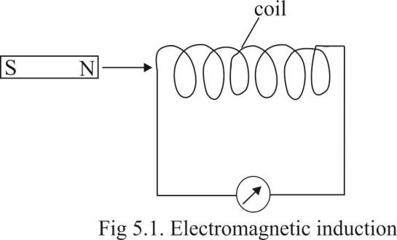

  - LAWS OF ELECTROMAGNETIC INDUCTION

Faraday’s Law
This states that whenever there is a change in the magnetic flux linked with a coil, an e.m.f is induced in the coil and the strength of the induced e.m.f. is directly proportional to the time rate of change of the flux linked with the coil.

Faraday's law can be expressed mathematically thus:
Induced e.m.f., E a ^{dф}
dt

where dф
dt
is the time rate of change of magnetic flux

Lenz’s Law
This states that the induced current always flows in such a direction as to oppose the motion producing it.

It was first stated by Henry Lenz, a Russian physicist in about 1835.
Lenz's law is simply an application of the law of conservation of energy. When a magnet for example, is moved towards a coil, an opposing force is experienced by the magnet. This means that work has to be done on the magnet to move it against the opposing force. The energy used in doing this work goes to produce an induced e.m.f in the coil.

Combining the two laws, we can write that

E a − dф
dt
or E = − k dф 5.1
dt

where k is a proportionality constant which is equal to unity when the quantities in equation 5.1 are in S.I units. The minus sign indicates Lenz's law. Hence, we can write that
dф
E = −
dt
For more than one turn of coil, E = − N ^{dф} ,
dt
where N is the number of turns of the coil.

Worked Examples
- The magnetic flux through a coil varies according to the relation ф = 6t² + 7t + 1
where ф is in milliwebers and t is in seconds. Find the magnitude of the induced e.m.f. in the coil when t = 2s?
ф = 6t² + 7t + 1
Magnitude of the induced e.m.f. |E| = dф = 12𝑡 + 7
dt
when t = 2s, |E| = 12(2) + 7 = 24 + 7 = 31 mV
- Calculate the e.m.f. induced in a coil of 200 turns placed in a field where the rate of change of flux is 0.01wbs⁻¹

𝐸 = −𝑁
𝑑ф
𝑑𝑡 = −200 × 0.01 = −2V

- Find the average induced e.m.f in a 500 − turn coil in which the flux is reduced from 7 × 10⁻⁵wb to
3 × 10⁻⁵wb in 0.5 seconds

Dф = 3×10−5− 7 x 10−5 = − 4×10−5

dt 0.5
0.5

= −8 × 10⁻⁵wbs⁻¹

𝐸 = −𝑁 𝑑𝜙 = −500(−8 × 10⁻⁵) = 0.04V
𝑑𝑡

Fleming’s right–hand rule (Dynamo rule)
Fleming stated a simple rule for predicting the direction of the induced current as follows:
If the thumb and first two fingers of the right hand are held at right angles and the first finger is pointed in the direction of the magnetic field and the thumb in the direction of motion then the second finger gives the direction of the induced current (Fig.5.2)
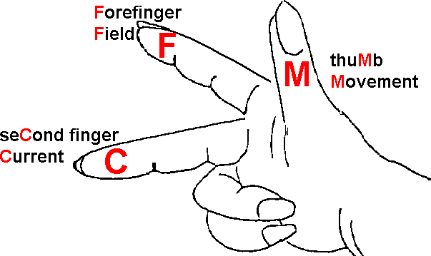
Fig 5.2 Fleming’s right –hand rule

Mnemonic: thuMb−Motion; firstFinger–field, seCond finger–Current

E.m.f. Induced in a Straight Conductor
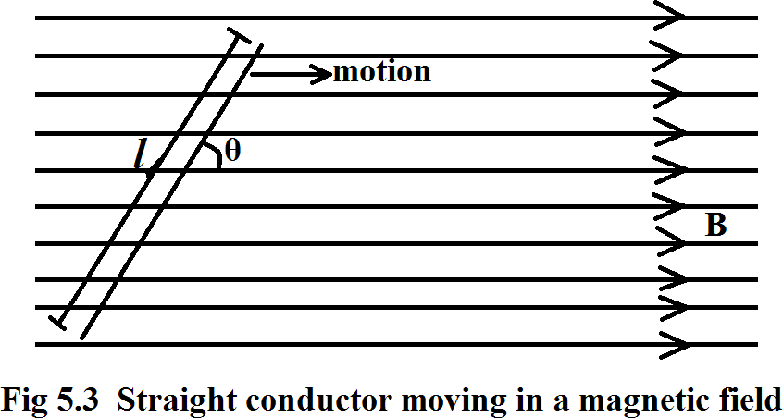

When a straight conductor is moved through a magnetic field such that it cuts through the lines of magnetic flux, an e.m.f. is induced between its ends.
Consider a straight conductor of length 𝑙 in a magnetic field of flux density B (Fig 5.3). If the conductor moves with velocity 𝑣 at an angle θ to the field direction, then the e.m.f., 𝐸 induced in it is given by
𝐸 = 𝐵𝑙𝑣𝑠𝑖𝑛𝜃………………….5.2

The e.m.f induced in the conductor is maximum when it moves at right angles (θ = 90⁰) to the field and is given by

E = BLv
No e.m.f is induced when the conductor moves parallel
(θ = 0⁰) to the field.

Worked Examples
- A 1.5m long straight conductor moves at a velocity of 800ms⁻¹ at an angle of 30⁰ to a magnetic field of 0.02T. Calculate the e.m.f. induced in the conductor.

The induced e.m.f.,E = BLvsinθ
= 0.02 × 1.5 × 800 × sin30⁰
= 12V

- An e.m.f of 1.375V is induced in a conductor of effective length 0.25cm. The conductor moves at right angles through a magnetic field at a velocity of 5ms⁻¹. Calculate the magnetic flux density of the field.
Since the conductor moves at right angles (θ = 90⁰) to the field then,
Induced e.m.f, E = Blv
1.375 = 𝐵 × 0.0025 × 5
1.375

𝐵 =

0.0025 × 5
= 110T

E.m.f Induced in a Rotating Coil
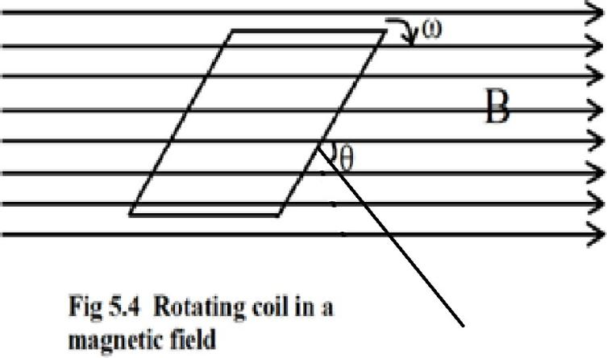
Consider a coil of N turns and area A being rotated at a constant angular velocity w in a magnetic field of flux density B.
When the perpendicular to the coil is at an angle 𝜃 to the field, the flux, 𝜙 through the coil is given by
𝜙= NBA cos θ
But, θ = wt
∴ 𝜙 = 𝑁𝐵𝐴 cos𝜔𝑡
The e.m.f., 𝐸 induced in the coil is given by

𝐸 = − 𝑑𝜙
dt
(Faraday's law)

𝐸 = −
d(NBA coswt)

dt
= −𝑁𝐵𝐴
d

dt
(cosω𝑡)

𝐸 = −𝑁𝐵𝐴 × −ωsinω𝑡
E = NBA wsinwt
𝐸 = 𝐸₀ sinωt

where 𝐸₀ = 𝑁𝐵𝐴𝜔 is the peak (maximum) value of the
e.m.f. This occurs when θ = 90⁰, i.e when the coil is in the plane of the field (Fig5.5)
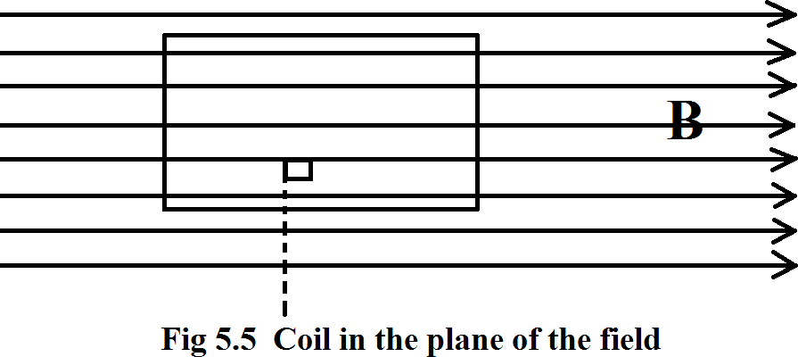

Worked Examples
- Calculate the maximum value of the e.m.f generated in a coil with 300 turns and of area 10cm² rotating at 60 radians per second in a field of flux density 0.2T
Maximum e.m.f, E₀ = NBAw
E0 = 300 × 0.2 × 10 × 10⁻⁴ × 60
= 3.6V
- A coil of 500 turns and with an area of 0.05m² is rotated 20 times per second in a field of flux density 0.2T. Calculate:
  - the maximum e.m.f. produced across the ends of the coil,

  - the torque required to maintain this rate of rotation if the current in the coil is 0.8A when the e.m.f. generated is a maximum
- Maximum e.m.f, E₀ = NBAw
N = 500 turns, B = 0.2T, A = 0.5m²
ω = 2πf = 2π × 20 = 40π rads⁻¹
∴ E₀ = 500 × 0.2 × 0.05 × 40π = 628.3V

- Maximum torque, Tmax = NBAI
= 500 × 0.2 × 0.8 × 0.05
= 4Nm

Uses of Induction Coil
- It is used in the coil-ignition system of motor cars.
- It is used in the operation of X - ray tubes.
- It is used in the study of electric discharge through gases.
- It is used in the investigation of high voltages.

  - Introduction
Chapter Six

INDUCTORS

Any conductor of an electric current can be regarded as an inductor. However, a practical inductor is usually formed into a cylindrical coil with many turns of conducting wire, as shown in Fig. 6.1
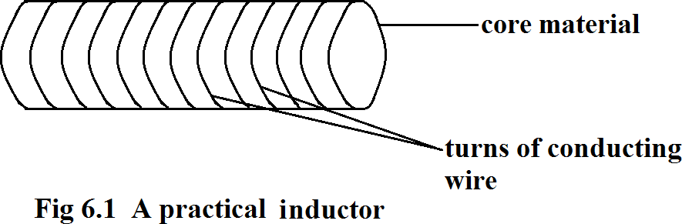

The terms coil and choke are also used for inductors. The core of an inductor may be made of iron, steel, plastic, or air.
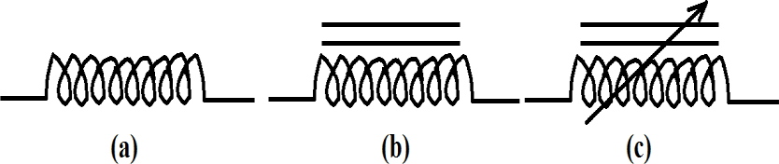
The circuit symbols for inductors are as shown in Fig. 6.2.
Fig 6.2 Circuit symbols for inductors:
(a) Air – core (b) Iron – core (c) Variable iron – core

The various types of inductors include; solenoidal wound inductor, toroidal inductor, and chip inductor.

Uses of Inductors
Inductors are used in:
- Power supplies
- Transformers
- Radio and TV receivers
- Radars
- Electric motors
- Telephone circuits
- Microphones and loudspeakers

Self – Inductance
When an electric current, 𝐼 flows through a coil (inductor), a magnetic flux 𝜙 is produced around the coil. The flux produced is directly proportional to the current.
Thus,
𝜙 x L
𝜙 = 𝐿𝐼 ………….6.1
where L is proportionality constant called the self- inductance of the coil. Equation 6.1 is valid when the number of turns of the coil is unity. For a coil with 𝑁 turns, we have,
𝑁𝜙 = 𝐿𝐼 ………………..6.2

The self-inductance (or simply inductance), 𝐿, of a coil is defined as the ability of the coil to induce voltage in itself when the current through it changes.

The unit of inductance is the henry (H), named in honour of the American physicist and inventor, Joseph Henry.
From equation 6.1,

d𝜙

dt
= I
dI

dt

But, d𝜙
dt
= induced voltage, V in the coil according to

Faraday's law.
∴ 𝑉 = 𝐿 𝑑𝐼 ……………….6.3
dt

V = L dl
dt
or V
𝑑𝐼⁄𝑑𝑡
…………..6.4

This implies that 1 henry equals 1 Volt-second per ampere (1H = 1VsA⁻¹).

Worked Examples
- Calculate the inductance of a coil that induces 40V when its current changes at the rate of 4As⁻¹.

𝐿L =
Vdl
dt
40
= 4 = 10H

- Determine the inductance of a coil that induces 1000V when its current changes at the rate of 50mA in 2µs.

l =
v
dl
dt
1000
= 50 × 10⁻³
2 × 10⁻⁶
1000
= = 0.04H or 40mH 25000

- The current through a 12-mH inductor (coil) is
4 sin100tA. Find the voltage across the inductor.

dl

dt
l = 4 sin 100t
= 4 × 100 cos100𝑡 = 400 cos100𝑡
dl
∴ 𝑉 = 𝐿
dt

= 12 × 10⁻³ × 400 cos 100𝑡
v = 4 .8 cos 100t
- The voltage across a 200 − mH inductor is given by
v (t) = 3t² + 2t + 4 volts for t > 0.
Determine the current I(𝑡t) through the inductor. Assume that 𝐼(0) = 1A .
dl
V = L dt
LdI =Vdt 𝑡 1
dL = L Vdt
1
𝐼 = 𝐿 ∫ 𝑉𝑑𝑡

II =
1
∫ 3𝑡²
L
1 3
+ 2t + 4 dt

2

I =
(t
L
+ t
+ 4t +c)

1
= 200 × 10⁻³
(t³ +t² + 4t + c)

= 5(t³ + t² + 4t + c)
= 5t³ + 5t² + 20t + 5c
At t = 0, I = 1A
∴ 1 = 0 + 0 + 0 + 5𝑐
1
c = 5

∴ 𝐼(𝑡) = 5𝑡³ + 5𝑡² + 20𝑡 + 5
1
(5)

I(t) = (5t³ + 5t² + 20t + 1)A

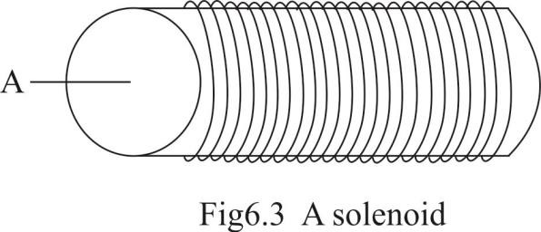
Inductance of a Solenoid

The inductance of an inductor (coil) depends on its physical dimension and construction. For example, for the solenoid shown in Fig 6.3,

Inductance, L =
𝜇r𝜇0N2A

l
…………….6.5

where 𝜇𝑟r = relative permeability
𝜇₀ = permeability of free space or air
N = number of turns
𝐴 = cross – sectional area of the solenoid
l = length of the solenoid.

Worked Examples
- Calculate the self–inductance of a solenoid 50cm long, 4cm in diameter and of 5000 turns. (Take permeability of free space = 4𝜋 × 10⁻⁷Hm⁻¹)

The core is made of free space or air and so 𝜇r = 1
𝜇r 𝜇0𝑁N2A
∴ The self-inductance, 𝐿 =
l
𝜇0 = 4𝜋 × 10⁻⁷Hm⁻¹, 𝑁 = 5000
𝐴 = 𝜋𝑟² = 𝜋 (0.02)² = 4.0 × 10⁻⁴𝜋 m²
l = 50cm = 0.50m
4𝜋 × 10⁻⁷ × 5000² × 4.0 × 10⁻⁴𝜋

∴ 𝐿 =
0.50

𝐿 = 7.90 × 10⁻²H = 79.0mH

- A solenoid 50cm long containing 2500 turns is wound on an iron core of radius 5mm and relative permeability

500. Find the flux through the solenoid when it carries a current of 2A.
Flux linkage, N𝑁𝜙 = LI = 𝜇r𝜇NAL𝑁2𝐴𝐼
𝑙

𝜙 =
𝜇𝑟𝜇0𝑁𝐴𝐼

𝑙

𝜇𝑟 = 500, 𝜇0 = 4𝜋 × 10⁻⁷Hm⁻¹, 𝑁 = 2500,
𝐴 = 𝜋𝑟² = 𝜋(0.005m)² = 2.5 × 10⁻⁵ 𝜋m²
I = 2A, l = 50cm = 0.50m
500 × 4𝜋 × 10⁻⁷ × 2500 × 2.5 × 10⁻⁵𝜋 × 2
∴ 𝜙 =
0.50
= 4.93 × 10⁻⁴
∴ The flux through the solenoid = 4.93 × 10⁻⁴wb

Mutual Inductance
Consider two coils with self–inductances 𝐿₁ and 𝐿₂ that are nearby to each other (Fig 6.4). For simplicity purpose, assume that the second coil carries no current.

When the current in coil 1 is changing, a voltage 𝑉₂ is induced in coil 2 due to some of the magnetic flux, 𝜙1, produced by coil 1 linking coil 2. This phenomenon is known as mutual induction.

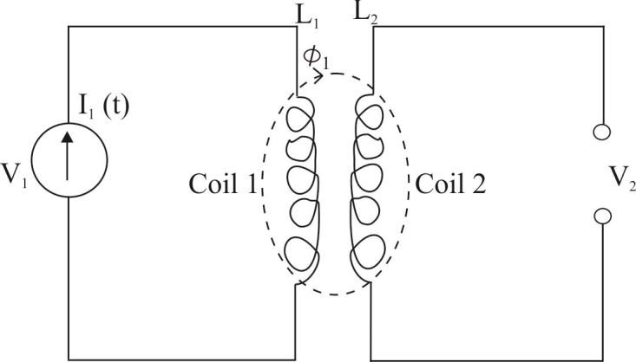
Fig 6.4 Mutual inductance

The ability of one coil (primary coil) to induce a voltage across a neighbouring coil (secondary coil) is known as the mutual inductance between the two coils.

The magnitude of the induced voltage, V in the secondary coil is given by
𝑉 = 𝑀 𝑑𝐼 …………………..6.6
dt
where 𝑀 is the mutual inductance between the two

coils and dl
dt
primary coil.
is the rate of change of current in the

From equation 6.6, we can write that M = V
𝑑𝐼⁄𝑑𝑡

It can equally be shown that 𝑀 = 𝑘√𝐿₁ 𝐿₂

where 𝑘 = coupling coefficient and 𝐿₁ and 𝐿₂ are self- inductances.
If k = 0, this implies that the two coils are far from each other and hence coupling is minimum or non- existent. If k = 1, this implies that all the flux produced by one coil links the other coil.

Worked Examples
- The current through a 10 − mH coil is increased from 0 to 5A in 5s. Calculate the e.m.f. induced in a second coil uniformly wound on it if the mutual inductance between them is 2mH.
The magnitude of the induced e.m.f, E is given by
dl
E = M
dt
𝑀 = 2mH = 2 × 10⁻³H, 𝑑𝐼 = 5 − 0 = 1A
dt 5
∴ 𝐸 = 2 × 10⁻³ × 1 = 0.002V = 2mV
- Two coils, one placed above the other have a mutual inductance of 0.5H.
  - How large is the average e.m.f produced in one coil when the current in the other is changed from 0A to 10A in 0.01 seconds?
  - If the secondary coil has 500 turns, what is the flux change in it?

- E = dl 𝑑dt
= 0.5(10−0) = 500V
0.01

𝐸 = 𝑁₂
d𝜙

dt
Faraday's law

∴ 𝑑𝜙 =
Edt

N2
500 × 0.01
= 500 = 0.01Wb

Arrangements of Inductors Inductors in series
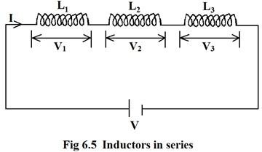

Consider a series connection of three inductors, as shown in Fig 6.5. The inductors have the same current through them.
The voltage, V = V1 + V2 + V3

But, V = L 𝑑𝐼 , V
= 𝐿
𝑑𝐼 , 𝑉
= 𝐿
𝑑𝐼 , 𝑉
= 𝐿
𝑑𝐼

𝑑𝑡 1
dL
1 𝑑𝑡
dl
2
dl
2 𝑑𝑡 3
dl
3 𝑑𝑡

∴ 𝐿 𝑑𝑡 = 𝐿1 𝑑𝑡 + 𝐿2 𝑑𝑡 + 𝐿3 𝑑𝑡
∴ 𝐿 = 𝐿1 + 𝐿2 + 𝐿3
where l is the resultant or equivalent inductance of the series arrangement.

In general, for any number of inductors in series, the equivalent inductance equals the sum of the individual inductances. Note that inductors in series are combined in the same way as resistors in series.

Inductors in Parallel
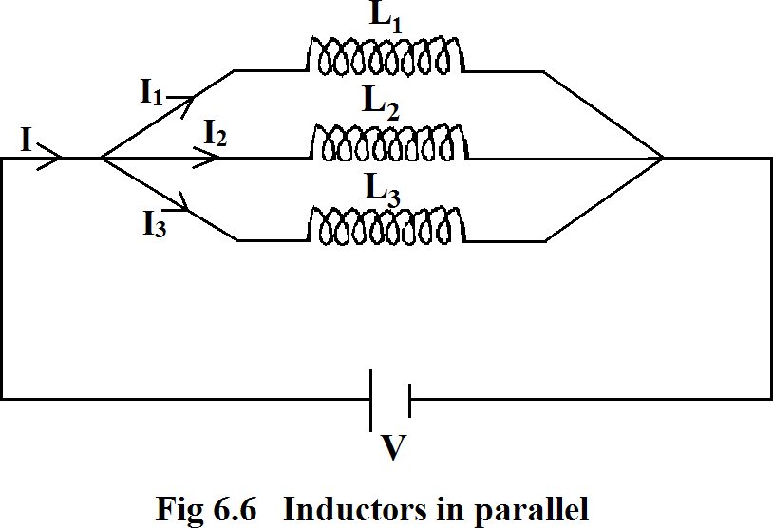

Now, consider a parallel connection of three inductors as shown in Fig 6.6. The inductors have the same voltage across them.
The current, I = I1 + I2 + I3

dl

dt
dI1
=
dt
dl2
+
dt
dl3
+
dt

But, dI
dt
= v from equation 6.3
l

and 𝑑𝐼1 = 𝑉
, 𝑑𝐼2 = 𝑉
, 𝑑𝐼3 = 𝑉

𝑑𝑡
𝐿1
∴
𝑑𝑡
V

L
𝐿2
V
= +
L1
𝑑𝑡
V

L2
𝐿3
V
+
L3

Dividing through by 𝑉, we have,

1 1
=
L L1
1
+
L2
1
+
L3

where L is the resultant or equivalent inductance of the parallel arrangement.
In general, for any number of inductors in parallel, the reciprocal of the equivalent inductance equals the sum of the reciprocals of the individual inductances.
Note that inductors in parallel are combined in the same way as resistors in parallel.

Worked Examples
- Find the equivalent inductance of the circuit shown in the figure below:
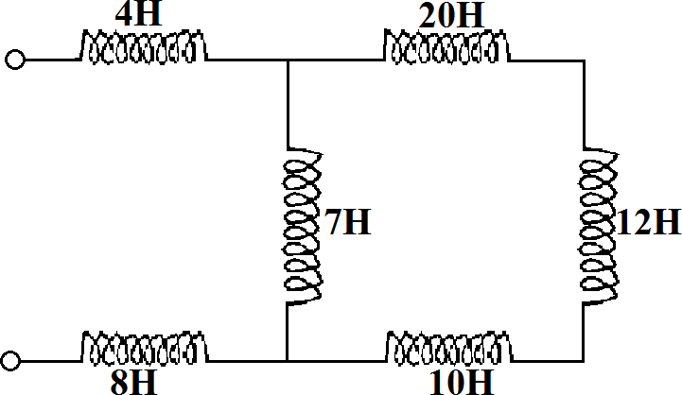

The 20 − H, 12 − H and 10 − H inductors are in series. The total inductance of this series combination
= 20 + 12 + 10 = 42H
This 42 − H inductor is in parallel with the 7 − H inductor. The total inductance 𝐿𝑝 of this parallel arrangement is given by:

1

L1
1 1
= +
42 7

1

L1
1 + 6 7
= =
42 42
42

L1 = 7 = 6H
This 6 − H inductor is in series with the 4 − H and 8 − H inductors. Hence, the equivalent inductance, 𝐿 of the circuit is given by
L = 4 + 6 + 8 = 18H
- Find the equivalent inductance in each of the circuits shown in the figures below:
(a)
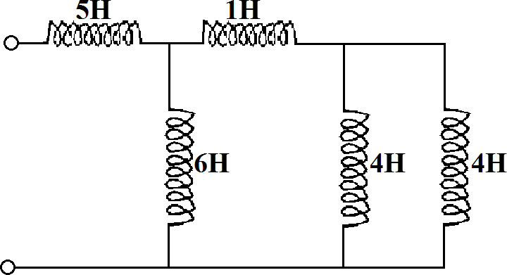

(b)
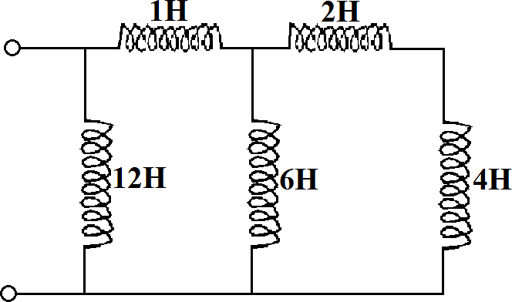
(c)
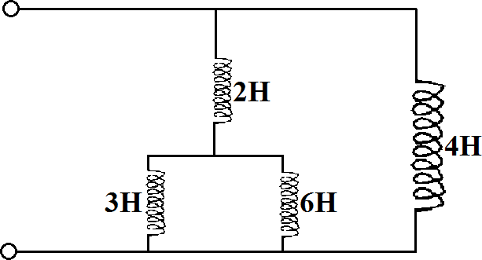

- The two 4 − H inductors are in parallel. Therefore, the resultant inductance of this arrangement

product
=
sum
4 × 4
=
4 + 4
16
= = 2H 8

This 2 − H inductor is in series with the 1 − H inductor and so the total inductance of this series combination
= 1 + 2 = 3H.
This 3 − H inductor is in parallel with the 6 − H inductor and the effective inductance of this arrangement

6 × 3
= =
6 + 3
18
= 2H
9

This 2 − H inductor is in series with the 5 − H
inductor.
Hence, the equivalent inductance, 𝐿 of the circuit
= 5 + 2 = 7H.

N.B: For any two inductors in parallel, equivalent inductance
product of the inductances
=
sum of the inductances

- The 2 − H inductor and the 4 − H inductor are in series
∴ Total inductance = 2 + 4 = 6H
This 6 − H inductor is in parallel with the other 6 − H
inductor.

∴ Resultant inductance =
6 × 6

6 + 6
= 3H

This 3 − H inductor is in series with the 1 − H inductor
∴ Total inductance = 1 + 3 = 4H
This 4 − H inductor is in parallel with the 12 − H inductor. Hence, the equivalent inductance of the circuit
12 × 4
= 12 + 4 = 3H

- The 3 − H and the 6 − H inductors are in parallel.

∴ The resultant inductance = 3 × 6 = 2H
3 + 6
This 2 − H inductor is in series with the other 2 − H
inductor.
∴ The total inductance = 2 + 2 = 4H
This 4 − H inductor is in parallel with the other 4 − H inductor. Hence, the equivalent inductance of the circuit

4 × 4
=
4 + 4
= 2H.

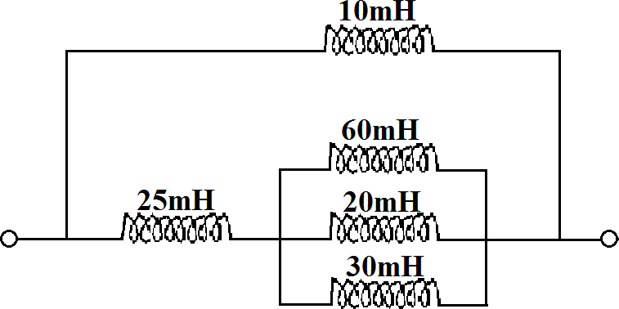
- Determine the equivalent inductance of the circuit in the figure below.

The 60 − mH, 20 − mH and 30 − mH inductors are in parallel. The resultant inductance, 𝐿𝑝 of this parallel combination is given by
1 1 1 1
= + +
Lp 60 20 30

1

Lp
1 + 3 + 2 6
= =
60 60
60

Lp =
= 10mH
6

This 10 − mH inductor is in series with the 25 − mH
inductor. The total inductance of this arrangement
= 25 + 10 = 35mH.
This 35 − mH inductor is in parallel with the 10 − mH inductor. Hence, the equivalent inductance of the circuit

10 × 35

10 + 35
7.778mH.
- A solenoid of 2X10⁴ turns has a length of 0.05m and radius of 0.014m. if the current in the solenoid is 3.5A, calculate the
  - inductance of the solenoid
  - magnetic flux through the solenoid
  - magnetic flux density
  - energy stored in the solenoid. ( Take µ₀ = 4𝜋𝑋 10⁻⁷𝐻/𝑚)

- Inductance, L = ^{μ0𝑁}2𝐴
L

4𝜋𝑋 10−7
4 2 2 ( )2

=
= 6.19H
(2x10 ) π 0.014
0.05

- Magnetic flux, ф = 𝐿𝐼 = 6.19x3.5
N 2 x 104

= 1.08 X 10⁻³ Wb.
- Magnetic flux density, B = ф
A

= 1.08 𝑋 10−3
π(0.014)2
= 1.754T

- Energy stored = ¹LI² = ¹ 6.19 x 3.5²
2 2
= 37.914J

Exercise 6
1(a) Define self-inductance.
- The magnetic flux through a 250−turn coil is 16 × 10⁻³Wb. If the current flowing through the coil is 1.0A, find the inductance of the coil.
- Calculate the e.m.f. induced in an 80 − mH coil in which the current changes by 150A in 0.05s
- State three applications of inductors.
2(a) With the aid of a labeled diagram, explain mutual induction
(b) The mutual inductance of the two coils of an induction coil is 30H. If a current in the primary of 1.5A falls to zero in 3ms, calculate the e.m.f. induced in the secondary coil.

